**BGP（Border Gateway Protocol）边界网关协议**

是一个自治系统间的路由选择协议（inter-autonomous system routing protocol）

**BGP提供的主要功能：**

obtain **subnet reachability information** from neighboring AS: eBGP

propagate **reachability information** to all AS-internal routers: iBGP

determine “good” routes to other networks based on **reachability information and policy**

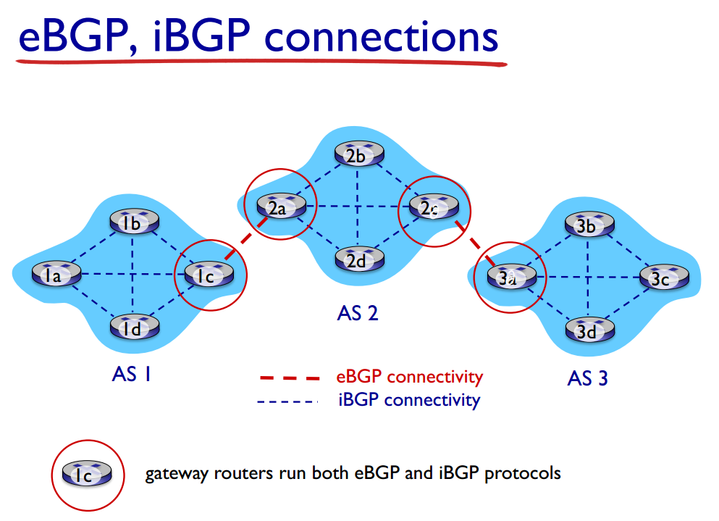

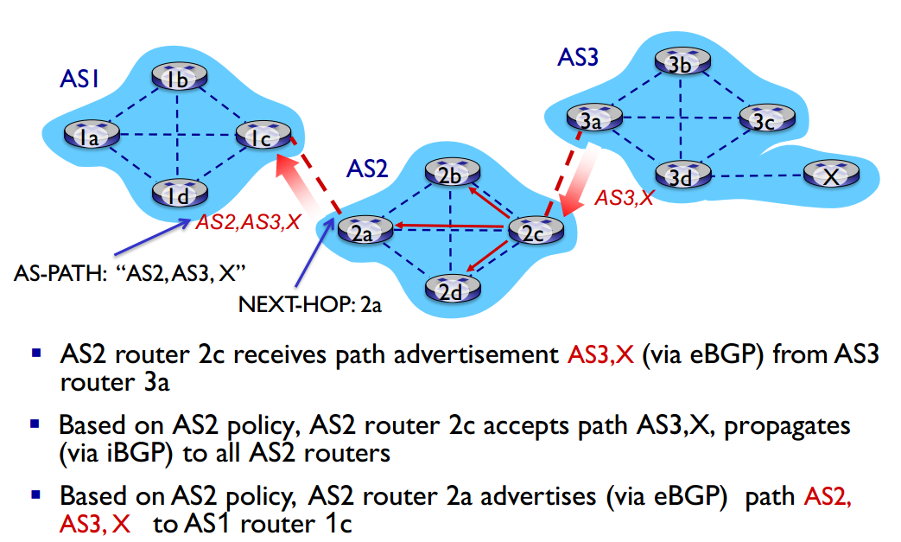

**BGP route selection**

router may learn about more than one route to

destination AS, selects route based on:

1. local preference value attribute: policy decision

2. shortest AS-PATH

3. closest NEXT-HOP router: hot potato routing

4. additional criteria

**Why different Intra-, Inter-AS routing ?**

policy:

inter-AS: admin wants control over how its traffic routed, who routes through its net

intra-AS: single admin, so no policy decisions needed

scale:

hierarchical routing saves table size, reduced update traffic

performance:

intra-AS: can focus on performance

inter-AS: policy may dominate over performance